Key information
For use in press releases, newsletters, websites, and more!
Safer Internet Day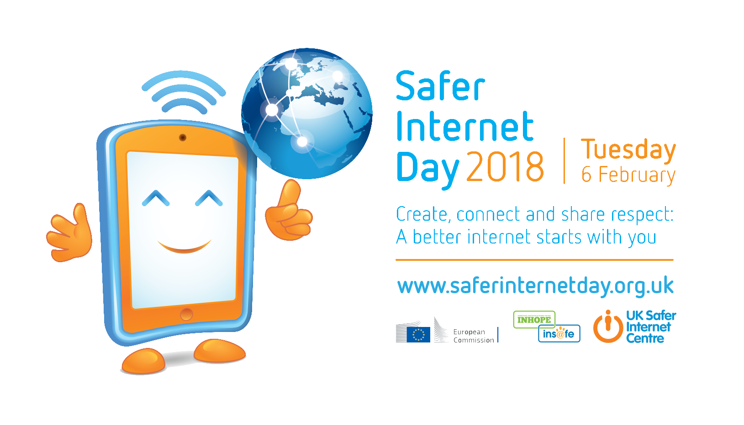
Safer Internet Day 2018 will be celebrated globally on Tuesday 6th February with the slogan ‘Create, Connect and Share Respect: a better internet starts with you.’
Coordinated in the UK by the UK Safer Internet Centre the celebration sees hundreds of organisations get involved to help promote the safe, responsible and positive use of digital technology for children and young people.
The UK Safer Internet Centre – a partnership of three leading charities; Childnet, the South West Grid for Learning and the Internet Watch Foundation – provide resources for children, schools and families, and tools for getting involved at www.saferinternet.org.uk.
Globally, Safer Internet Day is celebrated in over a hundred countries, coordinated by the joint Insafe/INHOPE network, with the support of the European Commission, and national Safer Internet Centres across Europe.
The day offers the opportunity to highlight positive uses of technology and to explore the role we all play in helping to create a better and safer online community. It calls upon young people, parents, carers, teachers, social workers, law enforcement, companies, policymakers, and wider, to join together in helping to create a better internet. Get involved to play your part!

#SID2018

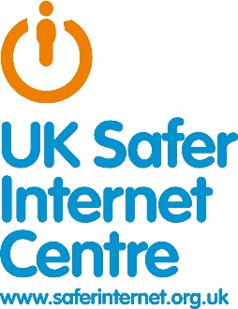
UK Safer Internet Centre
The UK Safer Internet Centre is a partnership of three leading charities – Childnet International, South West Grid for Learning (SWGfL) and the Internet Watch Foundation - with a shared mission to make the internet a better place for children and young people.
The partnership was appointed by the European Commission as the Safer Internet Centre for the UK in January 2011 and is one of the 31 Safer Internet Centres of the Insafe network.
The UK Safer Internet Centre delivers a wide range of activity to promote the safe and responsible use of technology by children and young people:
- coordinates Safer Internet Day in the UK, reaching millions every year
- founded and operates an online safety helpline for professionals working with children in the UK, including teachers and police officers
- operates the UK’s hotline for reporting online child sexual abuse imagery
- develops new advice and educational resources for children, parents and carers and teachers to meet emerging trends in the fast-changing online environment
- delivers education sessions for children, parents, carers, teachers and the wider children’s workforce, including free events across the UK
- trains children and young people to be peer educators and champions for the safe and positive use of technology
- shapes policy at school, industry and government level, both in the UK and internationally, and facilitates youth panels to give young people a voice on these issues.
For more information visit www.saferinternet.org.uk and the websites of the partners: Childnet, the Internet Watch Foundation and SWGfL.

