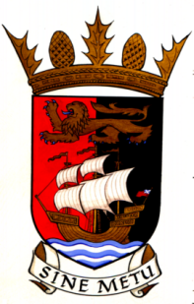

**WEDNESDAY 12th October 2022 at 7:00pm**

**AGENDA For Inaugural Meeting of newly formed Community Council**

1. Welcome
2. Apologies for Absence
3. Introductions and election of Convenor
4. Distribution of documents relating to CC
5. Election of other Office Bearers
6. Draft Minutes 14th September 2022
7. Matters Arising
8. Reports
9. Correspondence
10. AOCB

**NOTE:**

To save time - prior to the meeting please check the minutes for accuracy and any changes to what has been recorded so that we can quickly note these, adopt the minutes and move to matters arising.

**BO'NESS COMMUNITY COUNCIL**