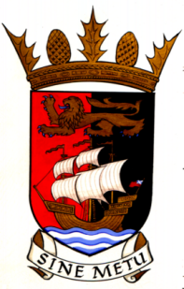

**WEDNESDAY 11th May 2022 at 7:00pm**

**AGENDA**

1. Welcome
2. Apologies for Absence
3. Draft Minutes 13th April 2022
4. Matters Arising
5. Linlithgow Community Council & M9 junction
6. Police Report
7. Reports
8. Correspondence
9. AOCB

**NOTE:**

To save time - prior to the meeting please check the minutes for accuracy and any changes to what has been recorded so that we can quickly note these, adopt the minutes and move to matters arising.

**BO'NESS COMMUNITY COUNCIL**